Contents
Overview 2
HR Reporting Environments 2
HR Reporting LIVE 2
HR Reporting QA 2
HR Reporting TEST 3
HR Reporting DEV 3
Data Sources 3
Viewing a data source 3
Amending the User Credentials data source 6
Amending the Service Account data source 7
1. Updating the HR Reporting environments 8
2. Updating the Visual Studio solution files 9
3. Updating the SSIS package components 10

Additional Guidance
Knowledge Article: not yet written
HOW TO - Manage Reports - Access Permissions within HR Reporting.docx
HOW TO - Manage Reports - Change Processes in OSM.docx
HOW TO - Manage Reports - Parameters.docx
HOW TO - Manage Reports - Release and Deployment.docx
HOW TO - Manage Reports - Shared Data Sources.docx
HOW TO - Manage Reports - Shared Datasets.docx
HOW TO - Manage Reports - Troubleshoot Common Errors.docx
HOW TO - Manage Reports - Visual Studio Basics.docx

Overview
The HR Reporting solution is a Microsoft-based user interface which allows users to run reports from the PeopleXD database within their web browsers. There are four environments (servers) for the HR Reporting solution, all of which are owned by the Microsoft Platform Services Team (MPST). MPST are responsible for any technical faults that arise in the environments, and for making any changes required to maintain the overall HR Reporting solution’s VPN connection to the PeopleXD database.

The day-to-day management of these environments is largely handled by the HRIS Analysis team, who own the report files, data sources, and datasets which are stored in each environment. This document focuses on the work carried out by the HRIS Analysis team.

 | NB: Software Solutions and Microsoft Platform Services manage a separate aspect of reporting via SQL Server Integration Services (SSIS); their processes are not detailed in this document. It’s important to note, however, that the password for the PeopleXD database service account is controlled solely by the HR Functional Analysis team, so if the SSIS connection to PeopleXD needs to be updated, the HR Functional Analysts are responsible for updating the service account password within SSIS.

HR Reporting Environments
The four HR Reporting environments are listed below.

HR Reporting LIVE

Database | Accessible to…
UOXP | - End-users (Departments and Central teams)  - Super-users (report writers)  - Microsoft Platform Services

The LIVE environment holds the current version of every active report and shared dataset. It is the primary environment of the HR Reporting solution. Changes to the LIVE environment will impact all report users, and must be handled very carefully.

HR Reporting QA

Database | Accessible to…
UOXP | - Super-users (report writers)  - Microsoft Platform Services  - End-users (ad hoc for testing purposes)

The QA environment is a copy of the LIVE environment and likewise holds the current version of every active report and shared dataset. It is also, as the name suggests, the Quality Assurance environment, where new or amended reports can be run against the UOXP database for final checks before being published to the LIVE environment.

The QA environment is restricted to super-users and MPST, but permission is granted to end-users on an ad hoc basis to enable them to test and sign off on any new/amended reports before those reports are made live. End-user access permissions must always be removed as soon as QA testing is complete.

HR Reporting TEST

Database | Accessible to…
UOXU, UOXC, or UOXZ (can be switched) | - Super-users (report writers)  - Microsoft Platform Services  - Project testing teams (ad hoc)

The TEST environment is used for running reports against the non-production databases (UOXU/UOXC/UOXZ), which is an essential component of testing PeopleXD system upgrades. TEST is not visible to end-users, however access can be granted to project testing teams as required.

The TEST environment’s data source connection strings can be updated to point at UOXU, UOXC or UOXZ, depending on which database a given project team wants to test.

HR Reporting DEV

Database | Accessible to…
UOXC, UOXU, or UOXZ (can be switched) | - Super-users (report writers)  - Microsoft Platform Services

The DEV environment is a development sandbox for report writers, where multiple iterations of a report may be stored and compared to one another throughout the report writing process. New and amended reports must be promoted through the four report environments from DEV > TEST > QA > LIVE as part of the change management process.

Data Sources
Every HR Reporting environment relies on its data sources in order to connect to the appropriate PeopleXD database for report queries. The LIVE and QA environments look at the UOXP database, while the DEV and TEST environments can be configured to look at UOXU, UOXC, or UOXZ.

 | NB: Only super-users and MPST are able to view/amend data sources in any of the HR Reporting environments. If you want to know the properties of a data source, or to change those properties in some way, you must contact the HR Systems Support team at hr.systems@admin.ox.ac.uk with your request.

Viewing a data source
Navigate to: Home > Data Sources

In any HR Reporting environment, the data sources are stored in a folder called “Data Sources”, which exists at the top level of the folder hierarchy. Navigate to this folder to view the data sources which have been set up for your environment.
Every environment must have the two following data sources:
- Oracle_DS_ServiceAccount: this data source is used by the shared datasets to provide lists of values for parameters.
- Oracle_DS_UserCredentials: this data source is used by the individual report datasets to run the report queries. It relies on people’s unique PeopleXD login credentials to retrieve information from PeopleXD’s database

Here is how the data sources appear within the “Data Sources” folder:

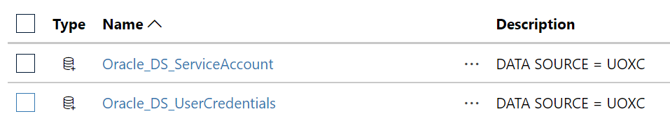

To view the details of a data source, click on its name. You will be taken to the Data Source Properties page.

Every data source has the following properties:

Property | Comments
Name | Name of the data source, e.g. Oracle_DS_ServiceAccount
Description | Used in the TEST & DEV environments to indicate whether the data source is currently looking at UOXU, UOXC or UOXZ.
Enable this data source (flag) | Indicates whether the data source is currently enabled in the environment – this flag should normally be ticked.

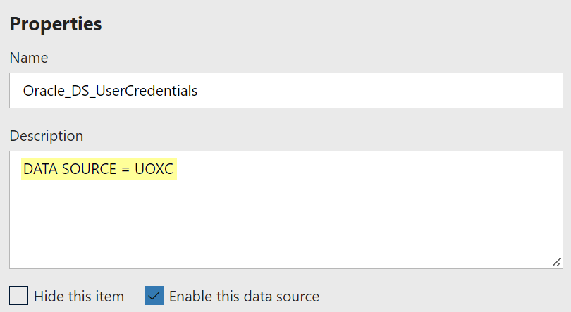

Property | Comments
Connection type | This will always be “Oracle Database”, because PeopleXD is Oracle-based software.
Connection string | This is the most important property. It tells the data source which PeopleXD database to connect to, e.g. UOXP, UOXU, UOXC, or UOXZ.

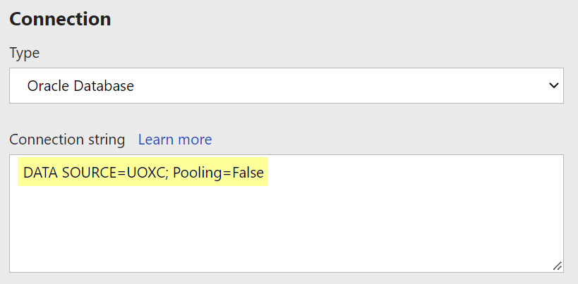

Property | Comments
Log into the data source… | This will be one of four options:  - As the user viewing the report. (This option is never selected.)  - Using the following credentials (username and password supplied) – this is only used for the Service Account data source.  - By prompting the user viewing the report for credentials (user prompted to supply their own username/password when accessing the report) – this is only used for the User Credentials data source.  - Without any credentials. (This option is never selected.)
Type of credentials | This will always be “Database username and password”.
Prompt | Whatever text should appear above the login fields for users. This value should not be changed without good reason, because whatever you enter here will appear in every report!

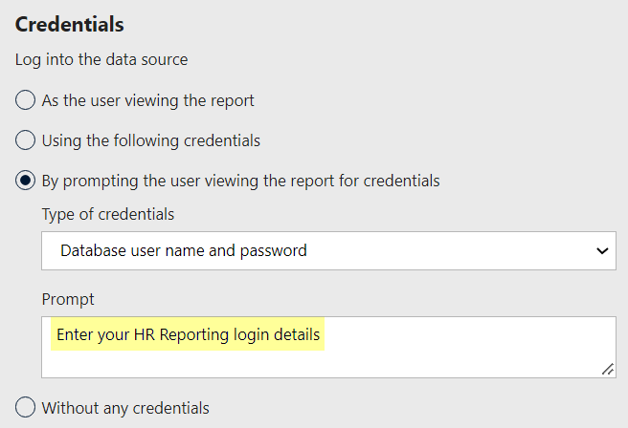

Here is what the prompt text looks like on a report:

Amending the User Credentials data source
 | NB: You must never change any of a data source’s properties unless absolutely necessary, because doing so risks disabling the data source.

Navigate to: Home > Data Sources

If you have the necessary permissions to amend data sources within the HR Reporting environments, you can do so by navigating to the “Data Sources” folder and selecting the Oracle_DS_UserCredentials data source:

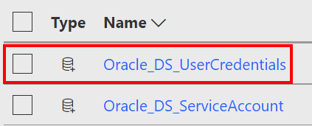

You will be taken to the Data Source Properties page. Make the changes you require, then click “Apply” to save the changes:

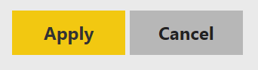

If you’ve altered the data source connection string to point to a different PeopleXD database, you can check that your changes will work before you apply them. Change the credentials to “Using the following credentials” and enter your own HR Reporting username and password:

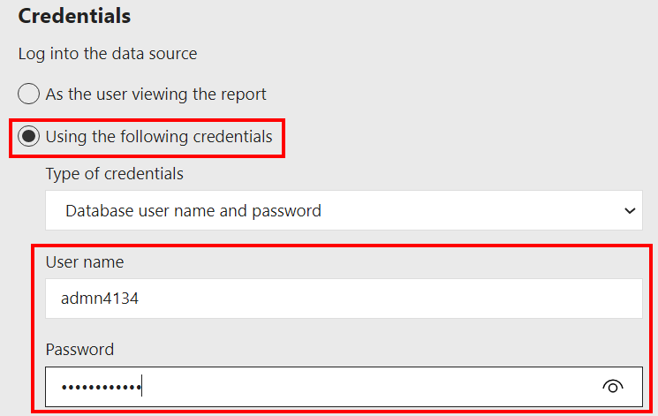

Now click “Test connection” at the bottom of the page:

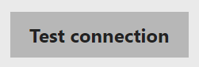

The report server will check that the credentials you have provided are able to connect to the PeopleXD database you have specified in the connection string. After a minute or two, you should get a status message:

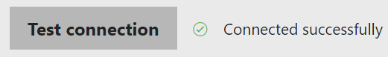

 | NB: If your connection test fails, check that you have entered the right login credentials. If your credentials are correct, it’s possible that the PeopleXD database is temporarily unreachable – the best advice here is to wait half an hour and try again.

Once you’re happy that your new connection string is working, you must change the credentials property back to “By prompting the user viewing the report for credentials”:



Click “Apply” to save your changes:



Amending the Service Account data source
The Oracle_DS_ServiceAccount data source connects to PeopleXD’s databases to retrieve the information which populates the shared datasets in each environment.

 | NB: The ServiceAccount data source is also used in exceptional circumstances to retrieve data for reports which time out when using the UserCredentials data source. Only a tiny number of reports use the ServiceAccount data source and the reasons for linking these reports to the ServiceAccount data source have been fully justified in each case in a formal OSM Change Request.

The Service Account has unlimited user sessions and unrestricted access to Core’s database, so it must be kept highly secure to prevent unwanted data breaches. Only a subset of reporting super-users know the login credentials for the Service Account data source, and they must periodically update these login credentials to keep the account secure.

The Service Account username is REPORT_POWERBI. This is static across all HR Reporting environments and must never be changed.

The Service Account password, on the other hand, must be updated annually. It must also be updated whenever a person with knowledge of the current password leaves the HR Functional Analysis team – this is to ensure that the password remains secure.

When the Service Account password changes, it must be updated in the following places:

- The HR Reporting environments
  - HR Reporting LIVE
  - HR Reporting QA
  - HR Reporting TEST
  - HR Reporting DEV
- The HR Reporting.sln files within Microsoft Visual Studio
  - HR Reporting_LIVE.sln
  - HR Reporting_QA.sln
  - HR Reporting_TEST.sln
  - HR Reporting_DEV.sln
- The components of the SSIS package managed by Software Solutions
  - PeopleXD.sln within Microsoft Visual Studio
  - PeopleXD.conmgr within Connection Manager
  - The environment profiles within SQL Server Management Studio
    - LIVE server: BI-SQLINT04.CONNECT.ox.ac.uk
    - UAT (QA) server: BI-SQLINT03-QA.CONNECT.ox.ac.uk
    - TEST server: BI-SQLINT02-T.CONNECT.ox.ac.uk
    - DEV server: BI-SQLINT01-D.CONNECT.ox.ac.uk

Updating the HR Reporting environments
To update the Service Account password in the HR Reporting environments, navigate to the Oracle_DS_ServiceAccount data source in each environment and go to its Properties page. Overwrite the existing password and then click the “Test Connection” button to ensure the Service Account can connect to PeopleXD using its new credentials:

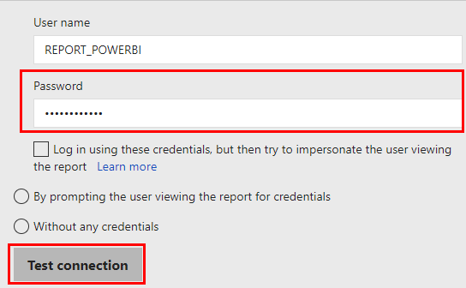
If the test is successful, click “Apply” to save your changes:

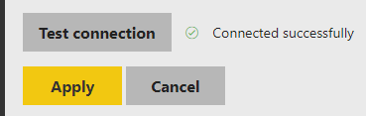

Repeat for all four HR Reporting environments.

Updating the Visual Studio solution files

To update the Service Account password in the Microsoft Visual Studio solution (.sln) files, launch each solution in Visual Studio. Click on the Oracle_DS_ServiceAccount data source within the Solution Explorer pane under the “Shared Data Sources” heading:

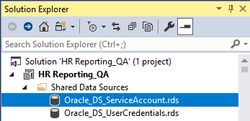

The Shared Data Source Properties window will pop up. Click the “Build…” button next to the Connection String field:

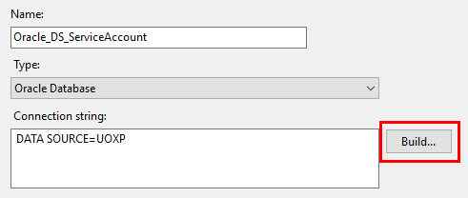

The Connection Properties sub-window will pop up. Overwrite the existing password and then click the “Test Connection” button to ensure the Service Account can connect to PeopleXD using its new credentials:

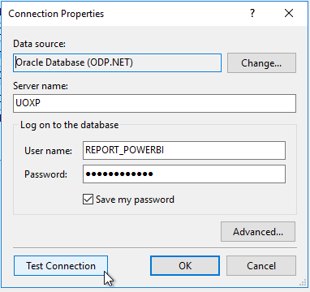

 | NB: Ensure the “Save my password” flag is enabled for the Service Account data source!

If the test is successful, click “OK” twice to save your changes and exit back to the Shared Data Source Properties window. Click “OK” again to close that window.

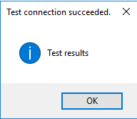

Now click the “Save All” icon in the menu bar (or hit Ctrl+Shift+S) to commit your changes to the solution file:

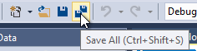

Repeat for all four HR Reporting solution files (.sln) in Visual Studio.

Updating the SSIS package components

The SSIS package and its components are owned and managed by the Software Solutions team (DEV and TEST) and the Microsoft Platform Services Team (UAT/QA and LIVE).

As of January 2021, we have the following contacts in both teams:
- Software Solutions
  - Ewan Kilgour, the Head of Data Reporting, Architecture and Modelling
  - Louise Brotchie, the Software Solutions Business Integrations & Technologies (SSM-BITe) team leader.
- MPST
  - Neil Smart, MS SQL Server Database Administrator
  - Saffron Greenwood, Team Leader Microsoft Platform Services

In order to update the SSIS package components with a new password for the PeopleXD service account, it is necessary to arrange a video call via Microsoft Teams with a member of either Software Solutions or MPST, depending on which environment you are editing.

Within the video call, the Software Solutions or MPST person will need to take the following actions to enable you to update the Service Account password in all the necessary locations:

- They must launch Visual Studio and open the PeopleXD.sln file. Within the .sln file, they must open the Connection Manager pane – this is where the password can be updated.
- They must open SQL Server Management Studio (SSMS) and open the environment profiles. Within each profile, they must open the Environment Variables section – this is where the password can be updated. Remember to contact the correct team depending on which environment profile you are updating:
  - DEV – owned by Software Solutions
  - TEST – owned by Software Solutions
  - UAT (QA) – owned by MPST
  - LIVE – owned by MPST

The person you are meeting will need to share their screen with you in Teams so that you can see the fields where the Service Account password must be updated. You will then have to request control of the screen. Click the button at the top of the video window to request control of your partner’s screen:



Once they have granted control, you will be able to click on and manipulate items on the shared screen as if they were on your own screen.

 | NB: Taking control of a shared screen often causes a lag between your actions and the changes onscreen. Your mouse may move slowly, and data you key in may take a moment to appear. This is normal.

Amend the password in the PeopleXD.sln file and within the SSMS environment profiles and save your changes. You can then give back control of the MS Teams screen to your meeting partner. Your meeting partner should perform a connection test to ensure that the new password is working correctly. Once they have confirmed this, you can end the meeting.

